**CREATE DEEP ENTITY**

Step 1 :

Create three Entities:

1. Class

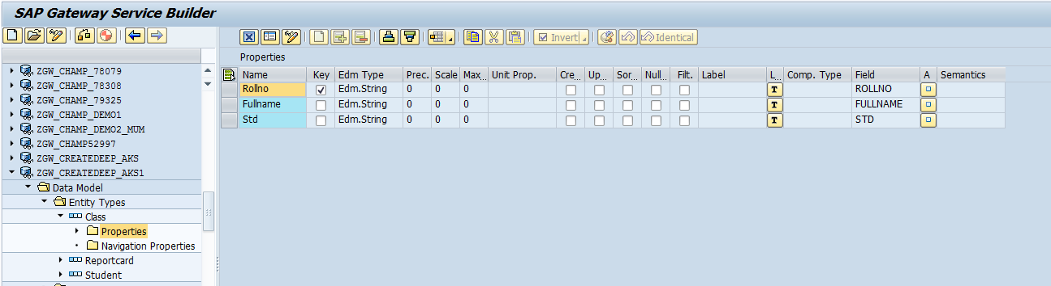

1. Reportcard

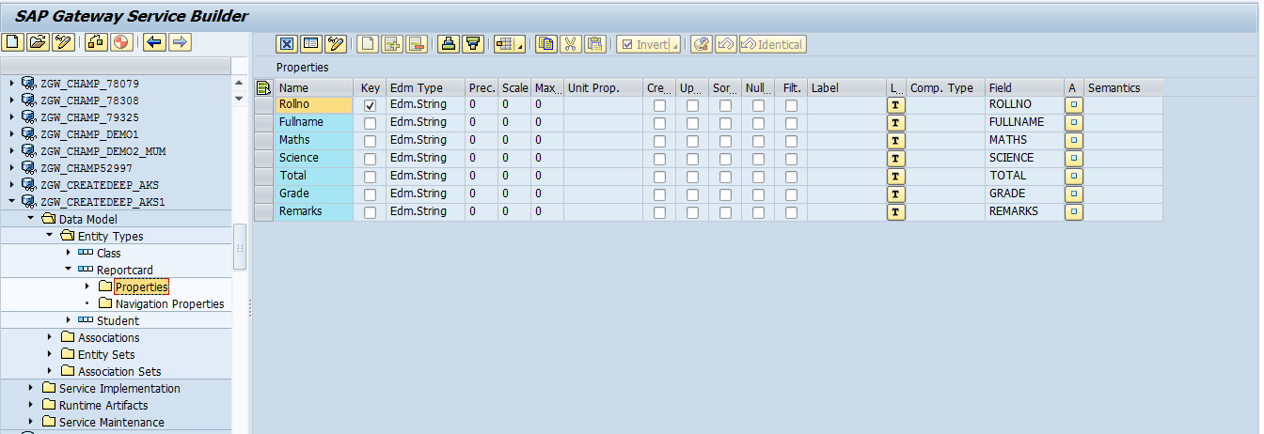

1. Student (Student is the header or parent entity)

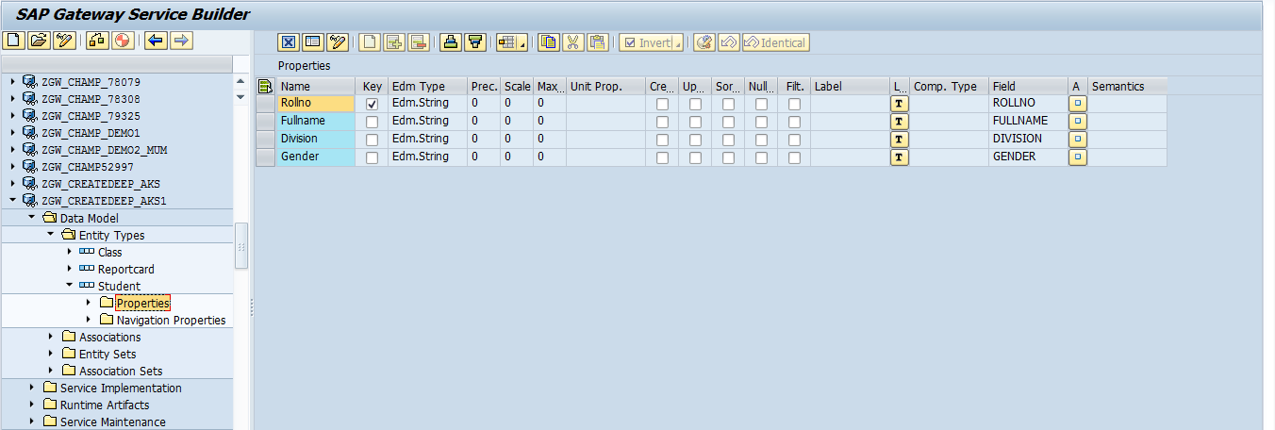

Step 2:

Association Properties

1. From Student to Class
2. From Student to Reportcard

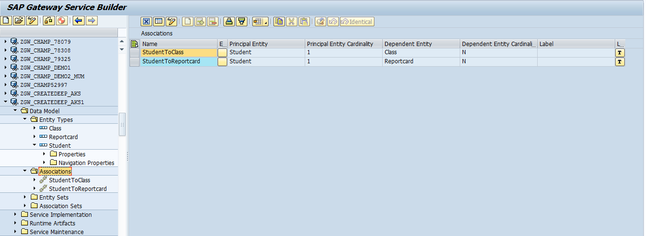

Step 3 :

Navigation properties: (Created automatically once the association properties are defined)

1. ClassSet
2. ReportcardSet

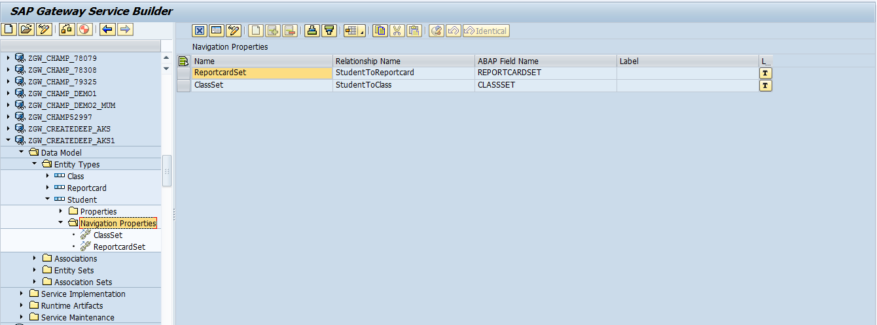

Step 4 :

Define **TYPES** (TS_DEEP_ENTITY) for deep entity in ZCL_ZGW_CREATEDEEP__01_MPC_EXT

CLASS zcl_zgw_createdeep__01_mpc_ext DEFINITION  
  PUBLIC  
  INHERITING FROM zcl_zgw_createdeep__01_mpc  
  CREATE PUBLIC .  
  
  PUBLIC SECTION.  
  
    TYPES:  
      BEGIN  OF ts_deep_entity ,  
        rollno        TYPE string,  
        fullname      TYPE string,  
        division      TYPE string,  
        gender        TYPE string,  
        classset      TYPE STANDARD TABLE OF ts_class WITH DEFAULT KEY,  
        reportcardset TYPE STANDARD TABLE OF ts_reportcard WITH DEFAULT KEY,  
      END OF ts_deep_entity .  
  
    METHODS define  
         REDEFINITION .

Step 5 :

Redefine the method **DEFINE** in ZCL_ZGW_CREATEDEEP__01_MPC_EXT

Coding :

  METHOD define.  
      super->define( ).  
  DATA:  
  lo_annotation     TYPE REF TO /iwbep/if_mgw_odata_annotation,  
  lo_entity_type    TYPE REF TO /iwbep/if_mgw_odata_entity_typ,  
  lo_complex_type   TYPE REF TO /iwbep/if_mgw_odata_cmplx_type,  
  lo_property       TYPE REF TO /iwbep/if_mgw_odata_property,  
  lo_entity_set     TYPE REF TO /iwbep/if_mgw_odata_entity_set.  
  
  lo_entity_type = model->get_entity_type( iv_entity_name = 'Student' ). "#EC NOTEXT  
  
  lo_entity_type->bind_structure( iv_structure_name  = 'ZCL_ZGW_CREATEDEEP__01_MPC_EXT=>TS_DEEP_ENTITY' ).   
  ENDMETHOD.

Step 6 :

Create Custom method **CUSTOM_CREATE_DEEP_ENTITY in** classZCL_ZGW_CREATEDEEP__01_MPC_EXT

With following parameters and exceptions

IV_ENTITY_NAME                          Importing            Type      STRING

IV_ENTITY_SET_NAME                 Importing            Type      STRING

IV_SOURCE_NAME                       Importing            Type      STRING

IT_KEY_TAB                                   Importing            Type      /IWBEP/T_MGW_NAME_VALUE_PAIR

IT_NAVIGATION_PATH                Importing            Type      /IWBEP/T_MGW_NAVIGATION_PATH

IO_EXPAND                                   Importing            Type Ref To        /IWBEP/IF_MGW_ODATA_EXPAND

IO_TECH_REQUEST_CONTEXT    Importing            Type Ref To        /IWBEP/IF_MGW_REQ_ENTITY_C

IO_DATA_PROVIDER                    Importing            Type Ref To        /IWBEP/IF_MGW_ENTRY_PROVIDER

ER_DEEP_ENTITY                           Exporting           Type      ZCL_ZGW_CREATEDEEP__01_MPC_EXT =>TS_DEEP_ENTITY

/IWBEP/CX_MGW_BUSI_EXCEPTION

/IWBEP/CX_MGW_TECH_EXCEPTION

Coding:

  METHOD CUSTOM_CREATE_DEEP_ENTITY.  
  
"Data Declaration  
    DATA:   lr_deep_entity TYPE zcl_zgw_createdeep__01_mpc_ext=>ts_deep_entity,  
            lt_class       TYPE zcl_zgw_createdeep__01_mpc_ext=>tt_class,  
            ls_class       TYPE zcl_zgw_createdeep__01_mpc_ext=>ts_class,  
            lt_reportcard  TYPE zcl_zgw_createdeep__01_mpc_ext=>tt_reportcard,  
            ls_reportcard  TYPE zcl_zgw_createdeep__01_mpc_ext=>ts_reportcard,  
  
            lt_istudent    TYPE TABLE OF zstudent,  
            ls_istudent    LIKE LINE OF lt_istudent,  
            lt_iclass      TYPE TABLE OF zclass,  
            ls_iclass      LIKE LINE OF lt_iclass,  
            lt_ireportcard TYPE TABLE OF zreportcard,  
            ls_ireportcard LIKE LINE OF lt_ireportcard.  
  
"Getting data from the Payload  
    io_data_provider->read_entry_data(  
    IMPORTING  
    es_data = lr_deep_entity ).  
  
"Putting data into the structure and then into their respective internal tables  
"Filling up Student Internal table  
    ls_istudent-rollno     =   lr_deep_entity-rollno.  
    ls_istudent-fullname   =   lr_deep_entity-fullname.  
    ls_istudent-division   =   lr_deep_entity-division.  
    ls_istudent-gender     =   lr_deep_entity-gender.  
    APPEND ls_istudent TO lt_istudent.  
  
"Filling up Class Internal table  
    FIELD-SYMBOLS: <ls_class> TYPE zcl_zgw_createdeep__01_mpc_ext=>ts_class.  
  
    LOOP AT lr_deep_entity-classset ASSIGNING <ls_class>.  
      CLEAR  ls_iclass.  
      ls_iclass-rollno          = <ls_class>-rollno.  
      ls_iclass-fullname        = <ls_class>-fullname.  
      ls_iclass-std             = <ls_class>-std.  
  
      APPEND  ls_iclass TO lt_iclass.  
      CLEAR: <ls_class>,ls_iclass.  
    ENDLOOP.  
  
"Filling up Reportcard Internal table  
    FIELD-SYMBOLS: <ls_reportcard> TYPE zcl_zgw_createdeep__01_mpc_ext=>ts_reportcard.  
  
    LOOP AT lr_deep_entity-reportcardset ASSIGNING <ls_reportcard>.  
      CLEAR  ls_ireportcard.  
      ls_ireportcard-rollno          = <ls_reportcard>-rollno.  
      ls_ireportcard-fullname        = <ls_reportcard>-fullname.  
      ls_ireportcard-maths           = <ls_reportcard>-maths.  
      ls_ireportcard-science         = <ls_reportcard>-science.  
      ls_ireportcard-total           = <ls_reportcard>-total.  
      ls_ireportcard-grade           = <ls_reportcard>-grade.  
      ls_ireportcard-remarks         = <ls_reportcard>-remarks.  
  
      APPEND  ls_ireportcard TO lt_ireportcard.  
      CLEAR: <ls_reportcard>,ls_ireportcard.  
    ENDLOOP.  
  
    INSERT zstudent     FROM TABLE lt_istudent.  
    INSERT zclass       FROM TABLE lt_iclass.  
    INSERT zreportcard  FROM TABLE lt_ireportcard.  
"Or Any other functionality needed such as calling the Function Module  
  ENDMETHOD.

Step 7 :

Redefine the method /IWBEP/IF_MGW_APPL_SRV_RUNTIME~CREATE_DEEP_ENTITY

  METHOD /iwbep/if_mgw_appl_srv_runtime~create_deep_entity.  
  
    DATA: custom_create_deep_entity TYPE ZCL_ZGW_CREATEDEEP__01_mPC_EXT=>ts_deep_entity.  
  
    CASE iv_entity_set_name.  
*————————————————————————-*  
*             EntitySet –  HeaderSet  
*————————————————————————-*  
      WHEN 'StudentSet'.  
*       Call the entity set generated method  
  
        CALL METHOD me->custom_create_deep_entity  
          EXPORTING  
            iv_entity_name          = iv_entity_name  
            iv_entity_set_name      = iv_entity_set_name  
            iv_source_name          = iv_source_name  
            it_key_tab              = it_key_tab  
            it_navigation_path      = it_navigation_path  
            io_expand               = io_expand  
            io_tech_request_context = io_tech_request_context  
            io_data_provider        = io_data_provider  
          IMPORTING  
            er_deep_entity          = custom_create_deep_entity.  
  
        copy_data_to_ref(  
        EXPORTING  
        is_data = custom_create_deep_entity  
        CHANGING  
        cr_data = er_deep_entity  
        ).  
    ENDCASE.  
  ENDMETHOD.

****************************************Coding Part is Done******************************************

GW Client

1. Using POST method with the following URI

/sap/opu/odata/sap/ZGW_CREATEDEEP_AKS1_SRV/StudentSet

1. Use the payload mentioned below

